A systematic approach to the colposcopy examination
Equipment check
The time to check your equipment is just before each clinic and not whilst examining a patient. If other colleagues also use the colposcope it is prudent to set up the colposcope eyepieces before the first patient arrives. A few simple steps will achieve this:
Setting up the colposcope: Achieving binocular focus
- Use a small object placed on the examination couch as the object of focus.
- Adjust the eyepieces to your own intra-pupillary distance: Start by placing the two eyepieces far apart and, whilst looking down both eyepieces simultaneously at the coin on the couch move the eyepieces closer together until the two images become one (Figure 1a).
- If a camera is attached (still or video) adjust the gross and then fine focus so that the image on the monitor is exactly focused on the coin (Figure 1b). This adjustment is performed whilst looking at the monitor, not down the colposcopic eyepieces.
- Fix the colposcope in position so that it becomes immobile by using the tension knobs on the supporting arms (Figure 1c). This may not be necessary with all models.
- Determine which eyepiece is in line with the camera (the primary eyepiece, (Figure 1d).
- Adjust the primary eyepiece so that the image on the monitor and that seen through the primary eyepiece are equally and correctly focused (Figure 1e).
- Adjust the second eyepiece so that it also is finely focused. This will mean that each eye and the monitor are in harmonious focus when examining the coin (Figure 1f). The colposcope is now ready for use with a patient.

Ergonomics of Colposcope
Loosen the tension knobs and move the colposcopy head into and out of position. The mechanism varies from one colposcope to another. You need to understand how to adjust the colposcope so it is at correct distance from your patient (usual fixed focal length is 300mm), at a comfortable height for you when seated and so that you have all equipment and trolley easily to hand. Also be aware of any trailing cables for safety.
Become thoroughly familiar with the light connections, the green filter switch, the magnification mechanism, camera head orientation as well as coarse and fine focusing.

Figure 1: Setting up the eyepieces for your eyes

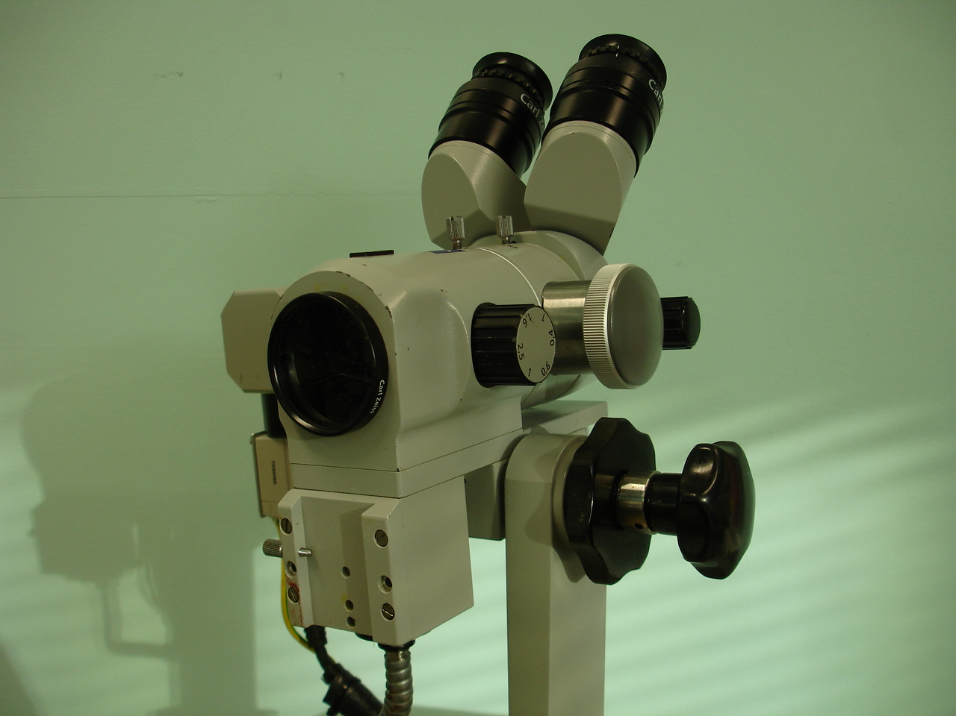  Eyepiece intra-pupillary adjustment knob | 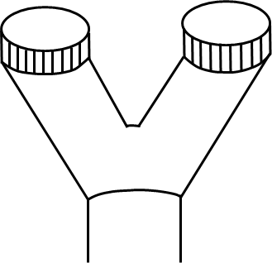  L  R

Figure 1a: Adjust the eyepieces to your own intra-pupillary distance: Start by placing the two eyepieces far apart and, whilst looking down both eyepieces simultaneously move the eyepieces closer together until the two images become one.

Camera
C-mount

Figure 1b: Here a camera is attached on the right side. It is attached via a C-mount attachment. Whilst looking at the monitor adjust the gross and then fine focus so that the image on the monitor is exactly focused on the coin.

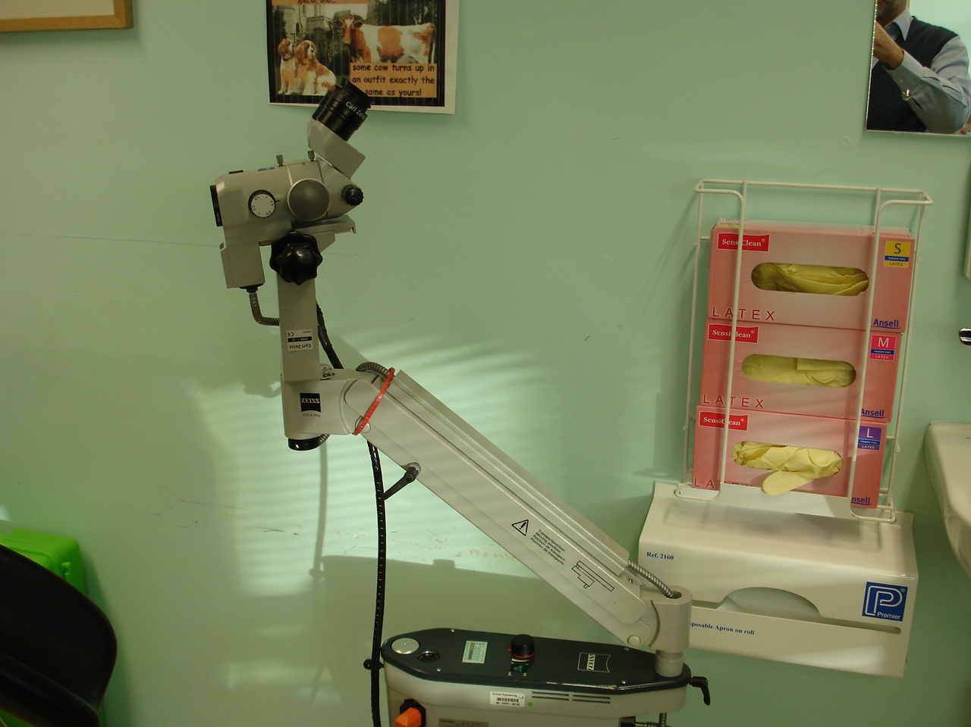
Tension control knob
Tension control knob

Figure 1c: Fix the colposcope in position so that it becomes immobile by using the tension knobs on the supporting arms.

Camera on right side

Figure 1d: The camera is attached here on the right side of the colposcope, i.e. on the same side as the colposcopists right eye.

Primary eyepiece
Figure 1e: Adjust the primary eyepiece, here the right eyepiece, so that the image on the monitor and that seen through the primary eyepiece are equally and correctly focused.

Left eyepiece

Figure 1f: The secondary eyepiece, here on the left, should now be adjusted so that it is in focus with the primary eyepiece and the monitor.

